GoFin

Automate your finance at lowest possible price (NO OCR, NO AI, need not share your bills/confidential info with any external service providers)

Let us go through each page one by one and see what it can do to help you keep your finance/accounts organised automatically (with minimal inputs for categorisation etc)

***Home Page***:

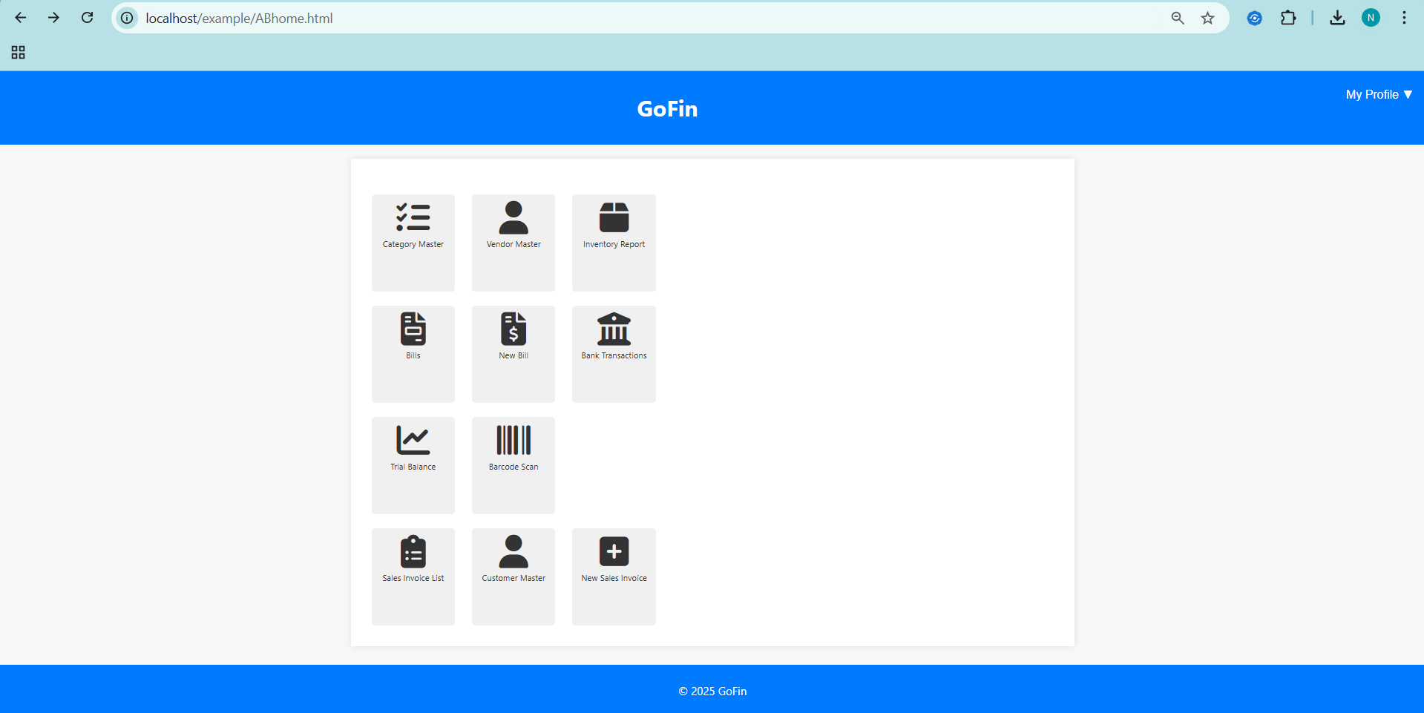

* Following modules are only functional:

1. Category master
2. Vendor master
3. Inventory report
4. Bills
5. New bills

***Category master:***

This is nothing but the GL master (general ledger). To keep it simple for SME’s and individuals who does not have accounting knowledge I named it as category master.

We have certain pre-defined/default GL/category masters such as CGST/SGST input GL, cash in hand GL etc. Users can import these GL if required.

Also, users can easily create new GL/categories as per their need with few clicks.

***Category master list:***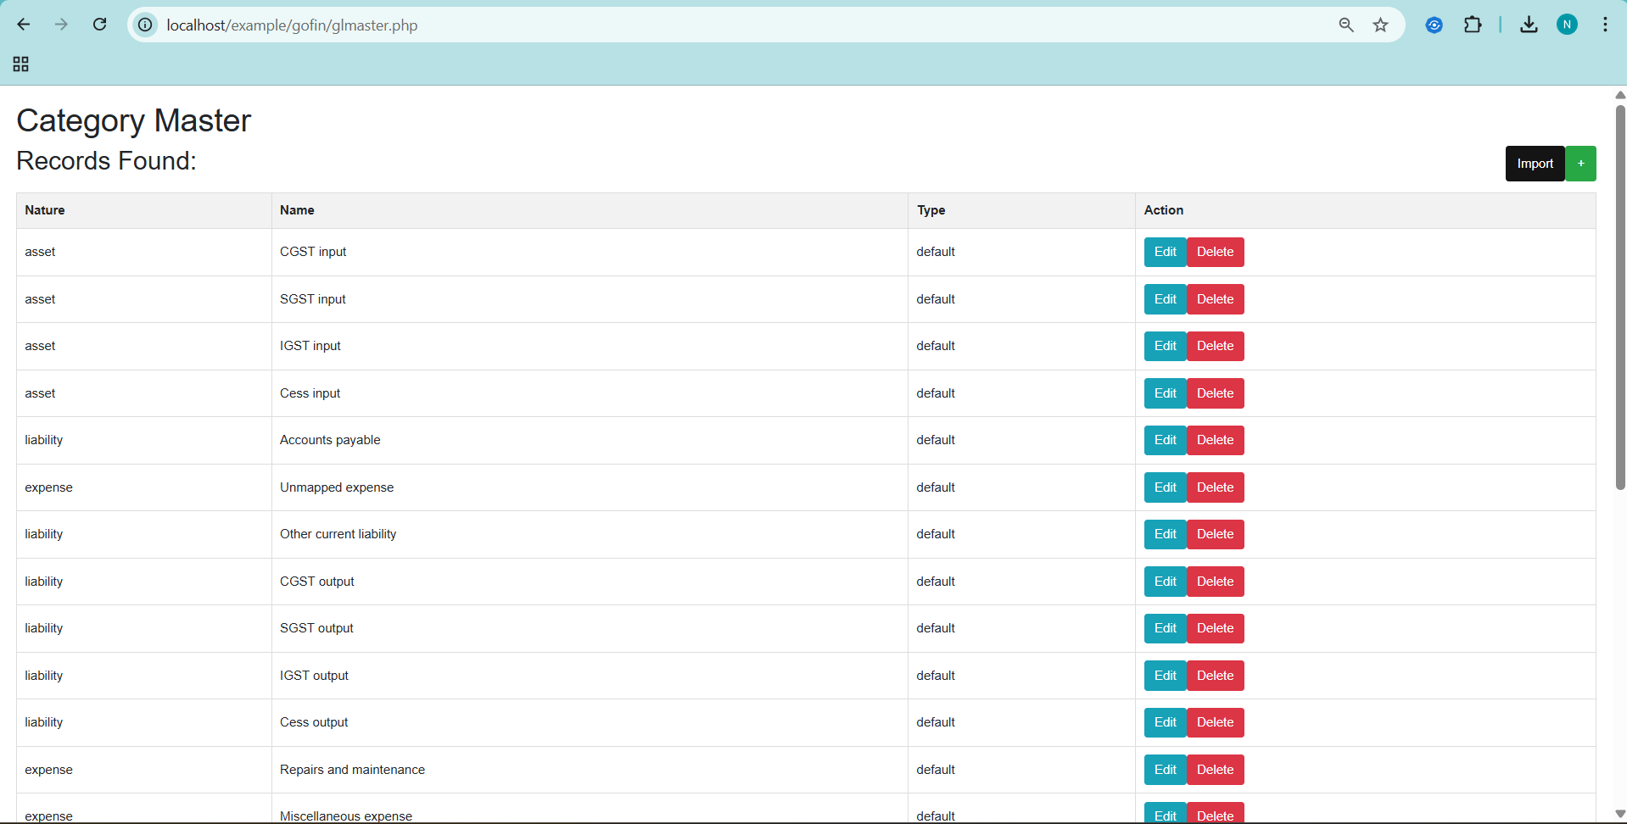

***Create new category:***

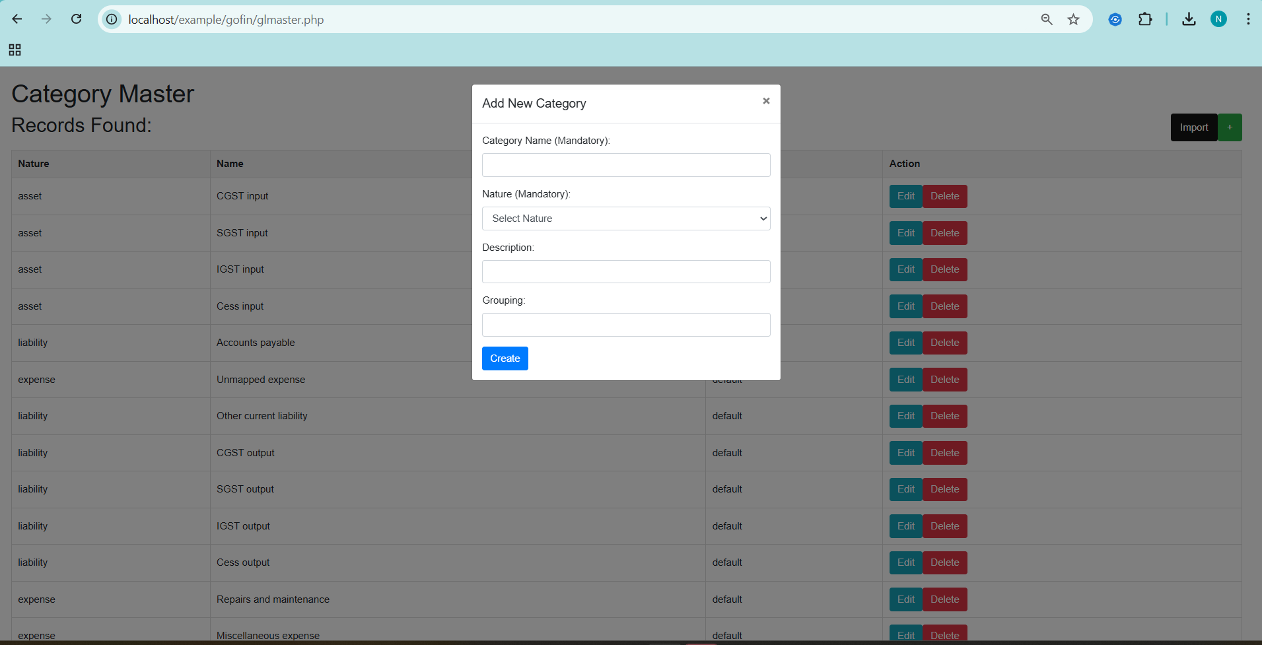

***Import default GL/categories if required:***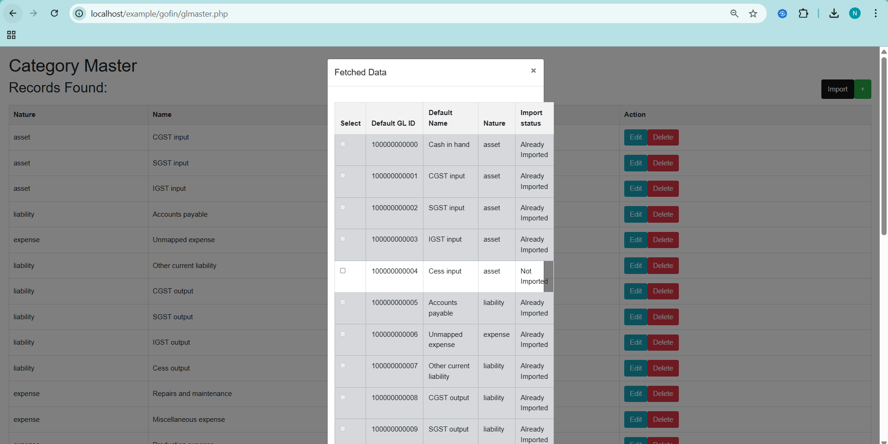

***Vendor master:***

All vendors are created automatically from the bills/einvoice. It also checks for existing records/vendors with same GSTIN/PAN. Hence avoids duplicates.

All vendors can be mapped to certain categories of expenses in this page. All new bills will be recorded based on the new mapping available in master. If no updates are made then by default it is tagged to unmapped GL (P&L) and other current liability (BS).

***Vendor master list:***

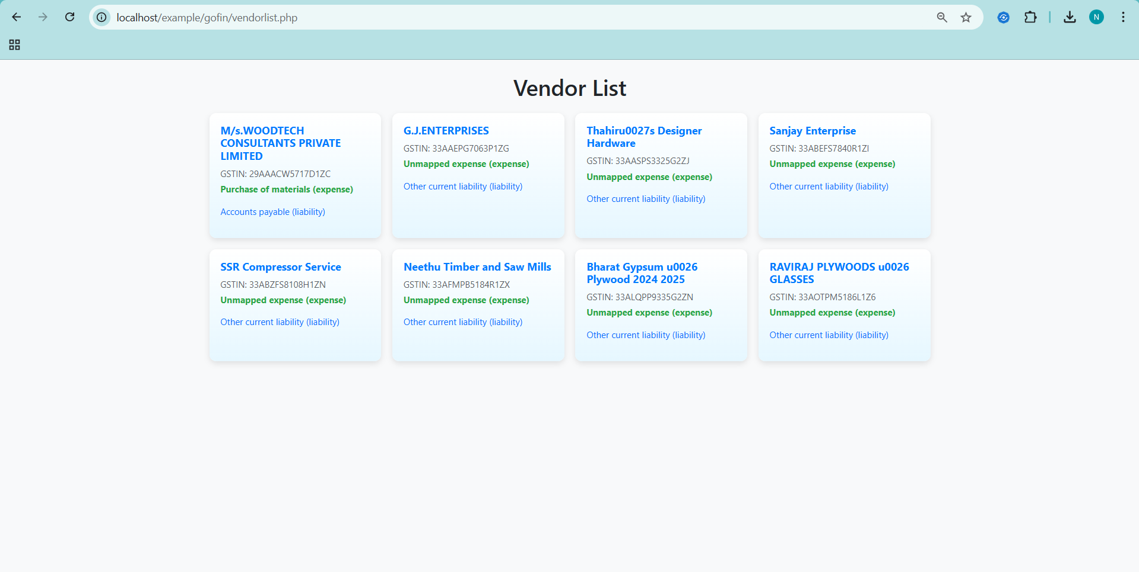



***Edit vendor master:***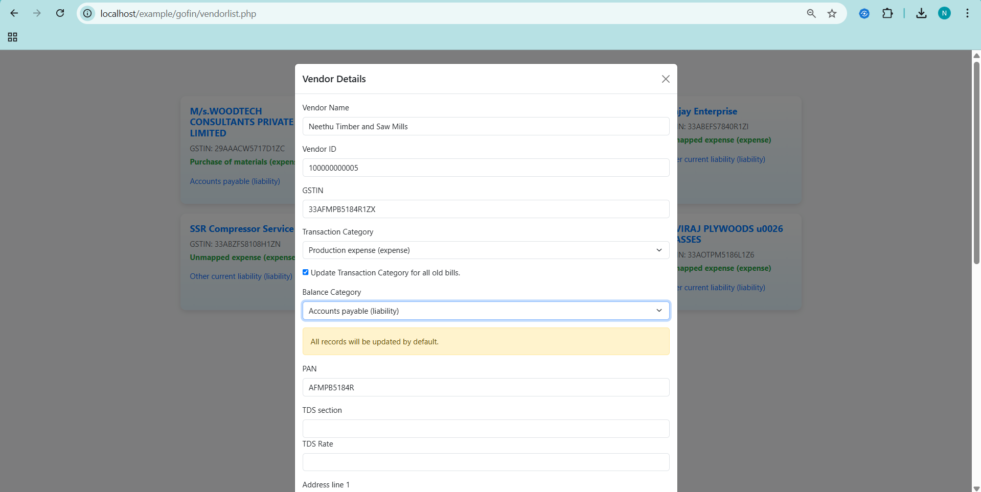



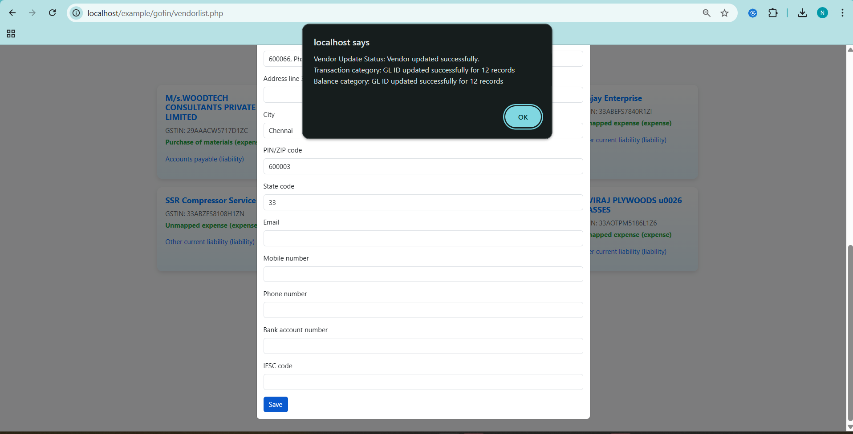



***Inventory master:***

Inventory items can be created on the go while processing bills(with few clicks). If there is exiting item with same product description/EAN/UPC(barcode) then it auto picks the inventory item code when processing bill to update inventory.

***Inventory master list:***

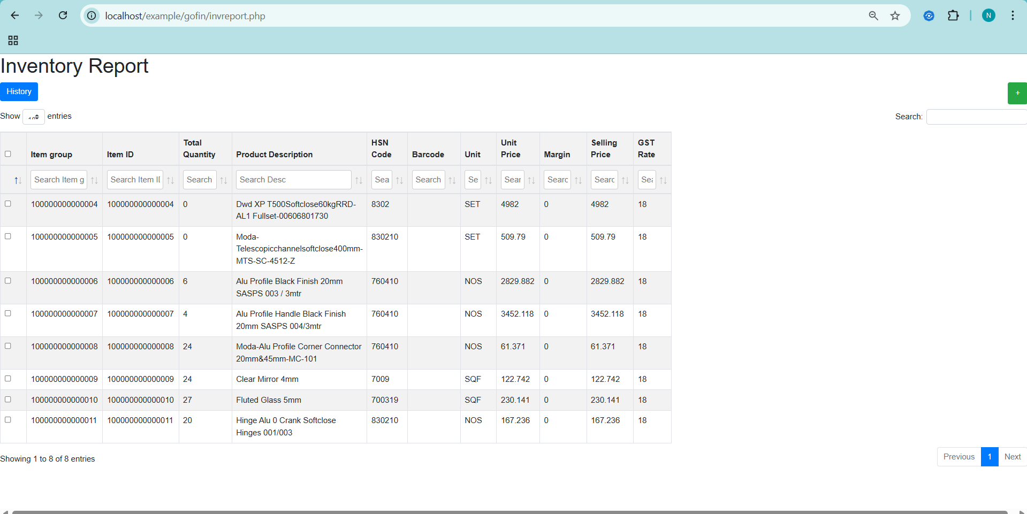

***Inventory item history:***

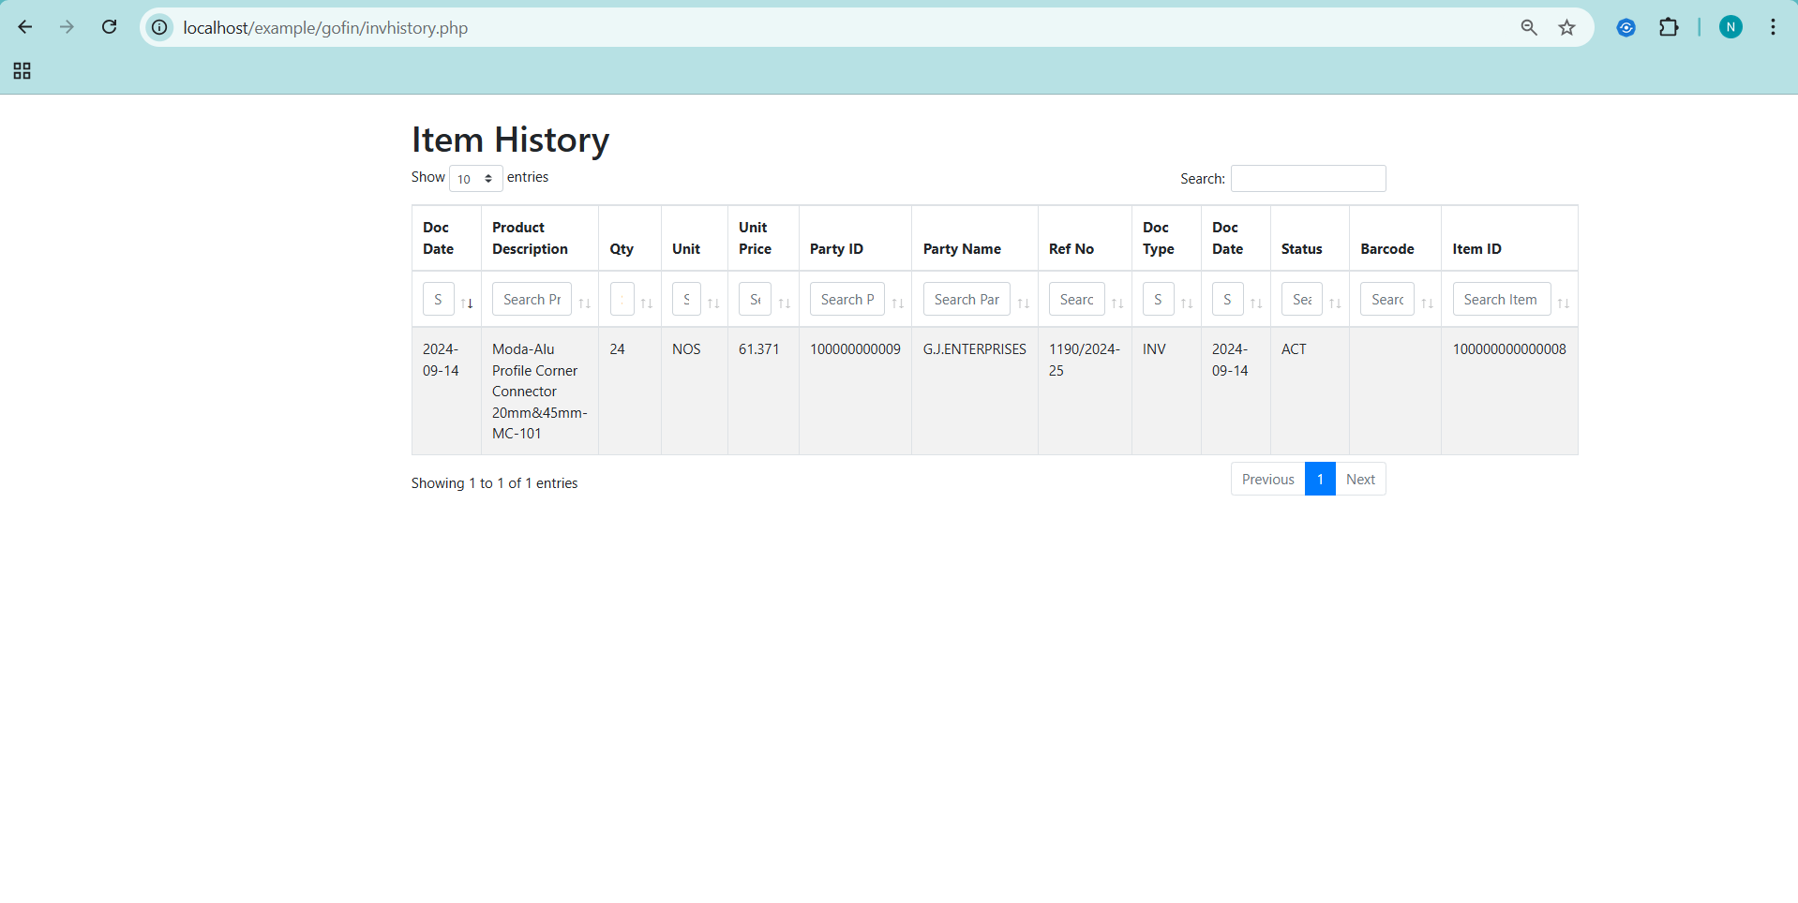

***Bills:***

We can view all bills here. Also all categories can be updated.

***Bills list:***

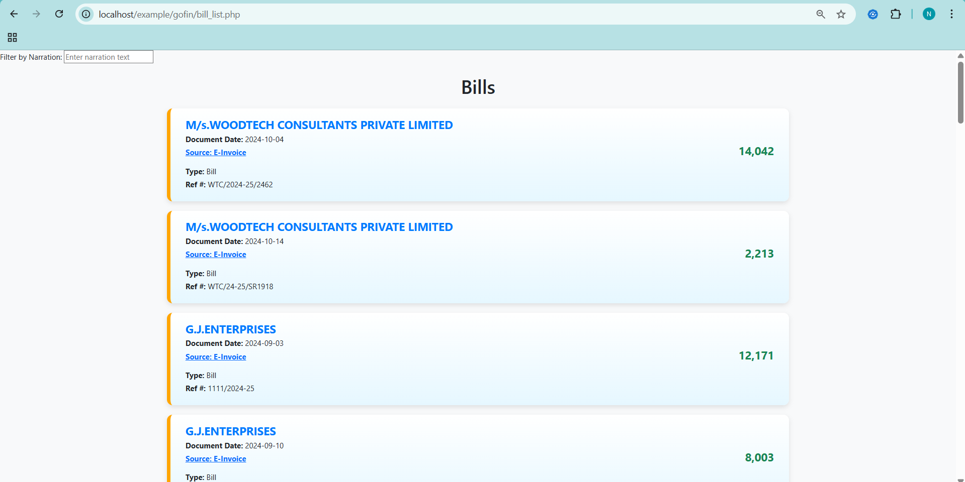

***Bill detailed view:***

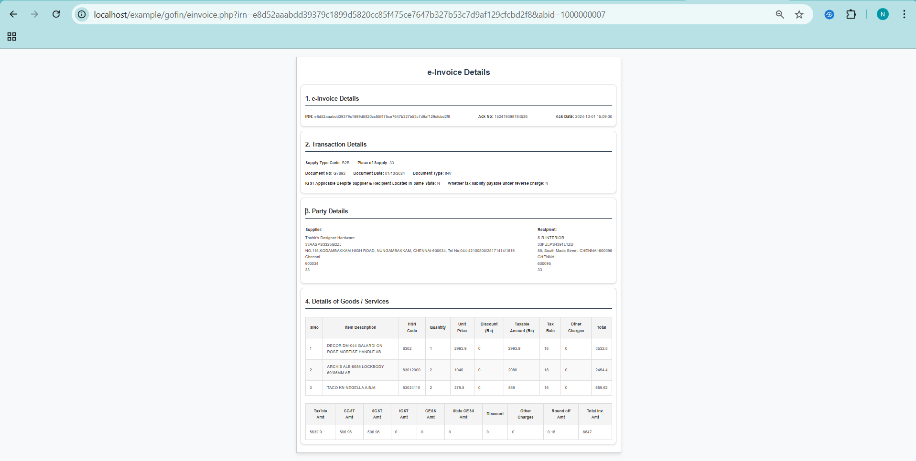

***Edit bill:***

Following field can be edited and it automatically adjusts journal as per updated records:

1. Posting date
2. Is this bill subject to reverse charge under GST?
3. Are you availing input tax credit?
4. Do you want to itemise/update inventory records?
5. And the expense category for this bill.

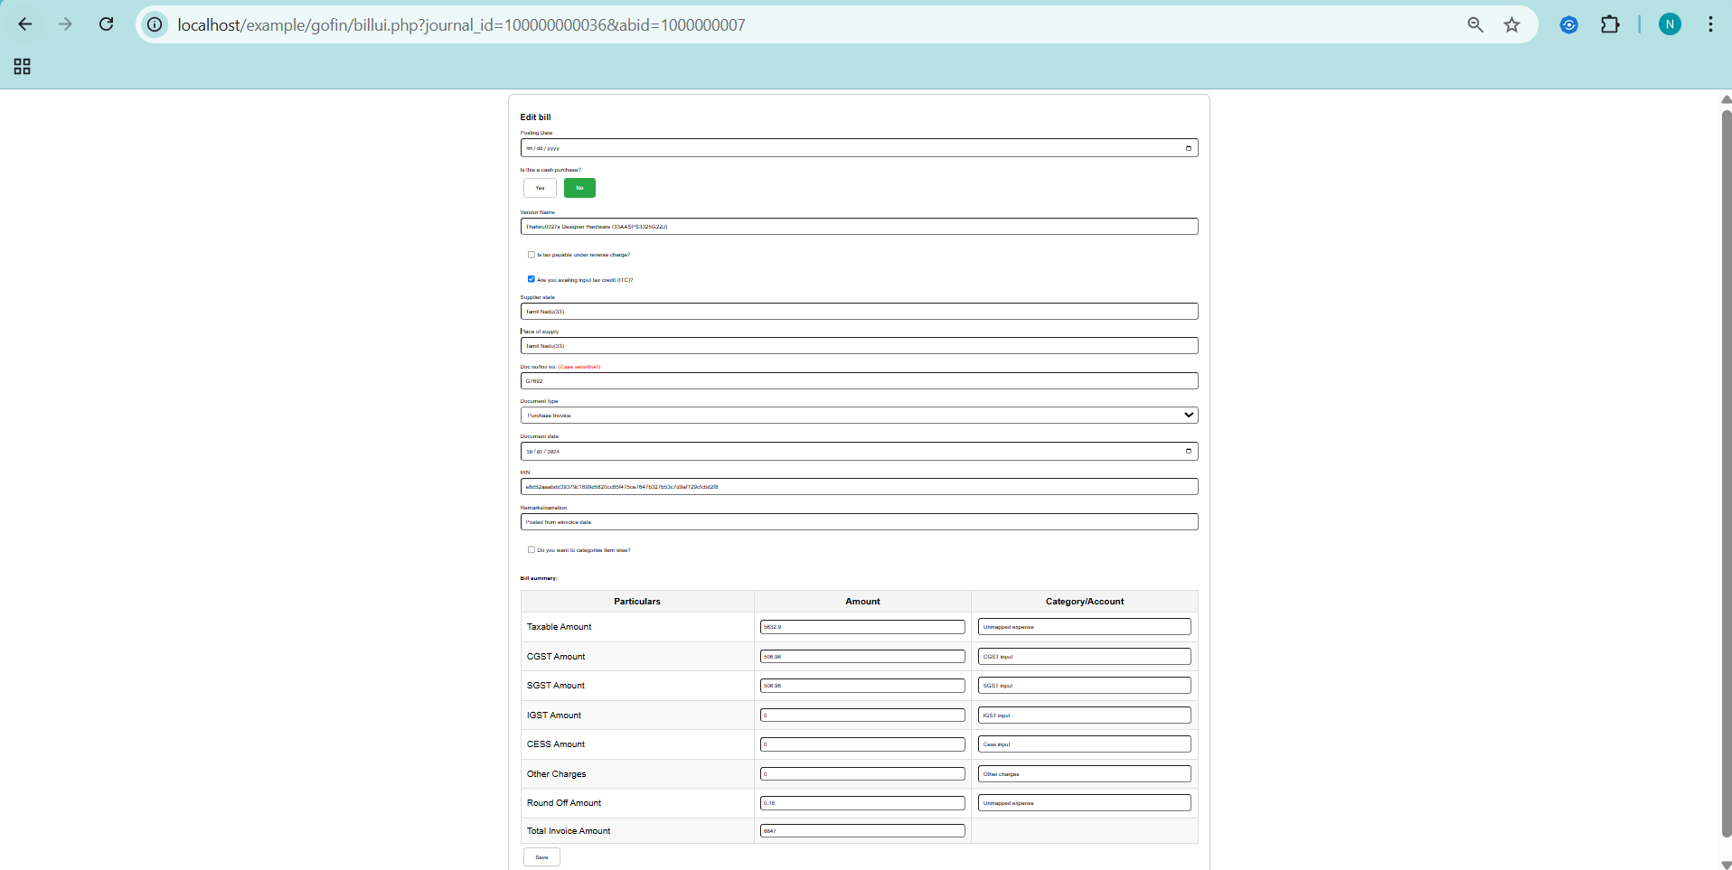

***Edit bill-itemise:***

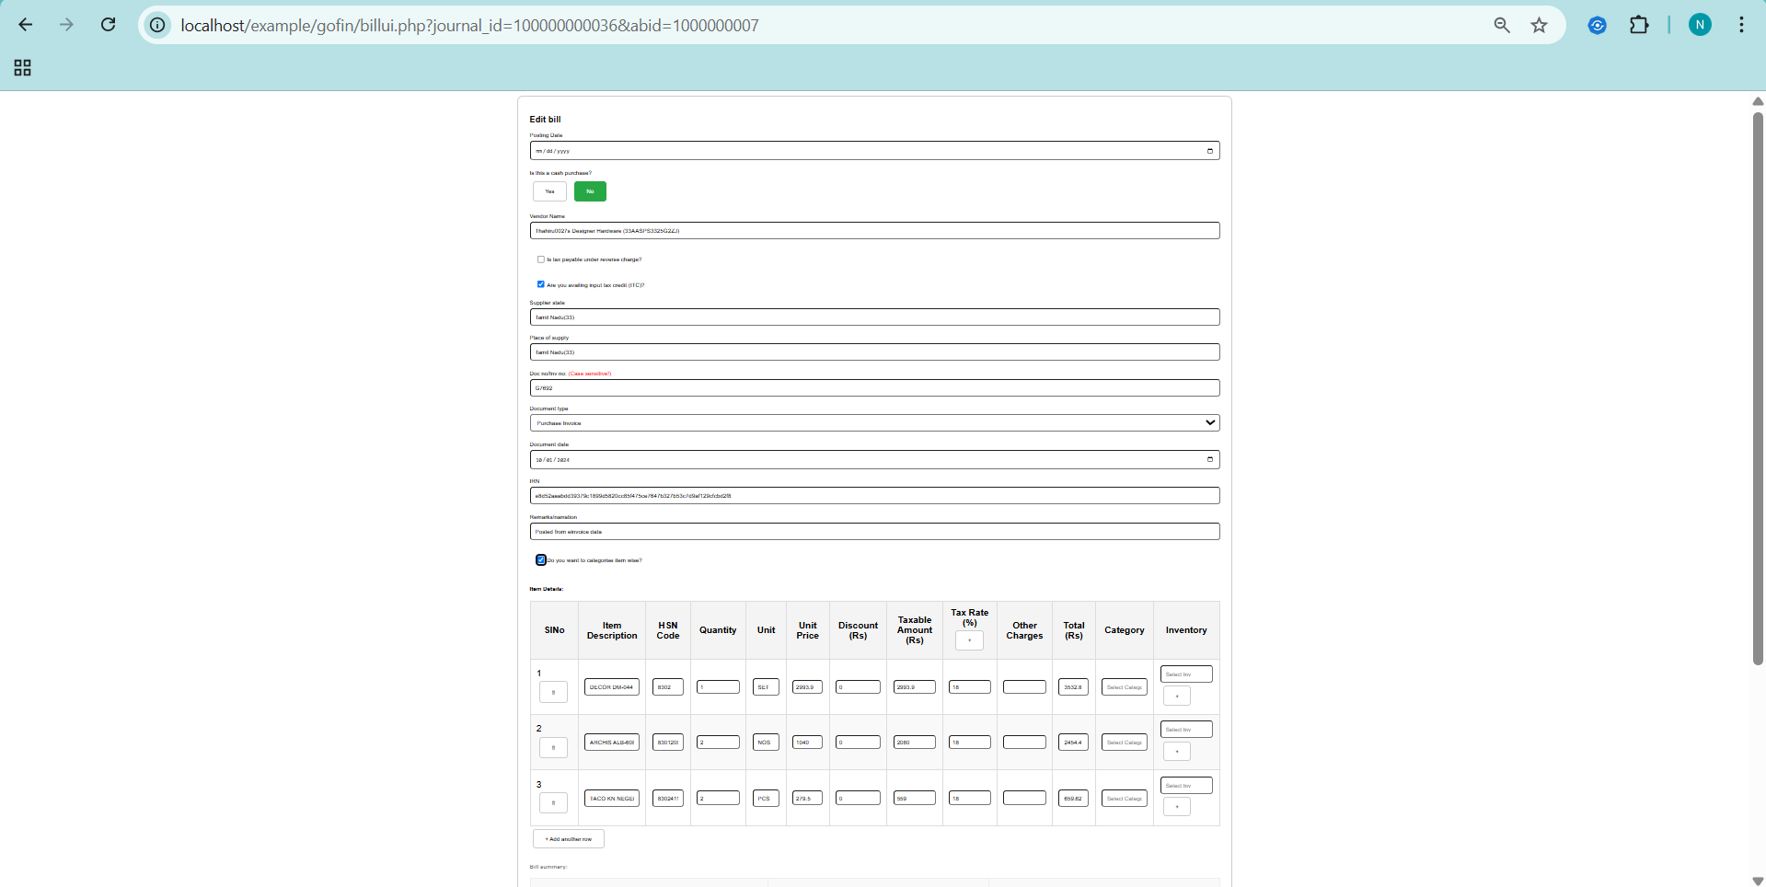

***Create new item from bill:***

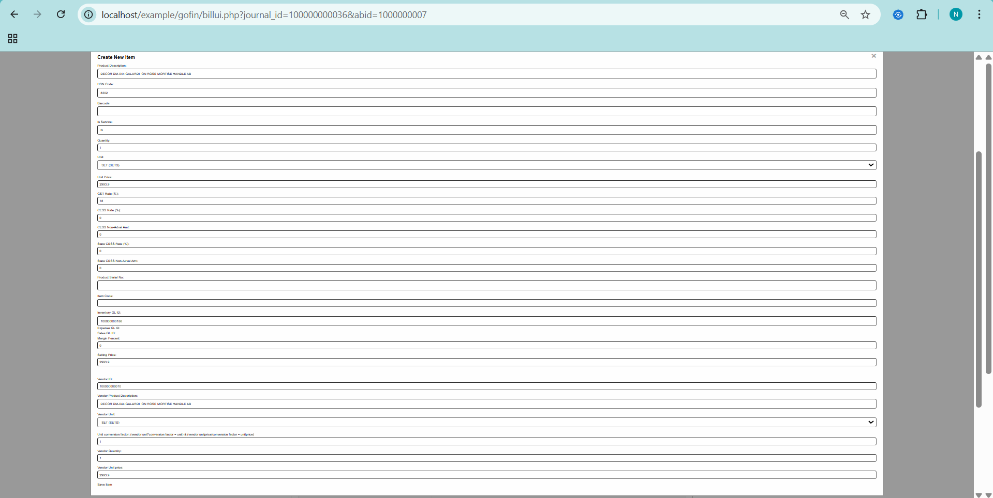

***Edit bill UI updated with new item code:***

